CLEVNET App Instruction

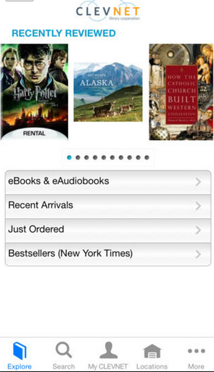

1. The CLEVNET app can be downloaded on an iOS or Android device. You are able to:
   * Search for items in the catalog
   * Place items on hold
   * Renew items
   * Check on the status of items on hold and items checked out
   * Check on fines
   * See which library within the CLEVNET system holds a certain item
2. To search – Click on the search button at the bottom of the screen.

* Search for item using keyword, title or author.
* You can also scan the barcode of a book you find at a store to see if the library has a copy.
* 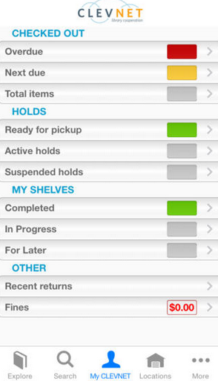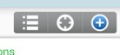Once you find an item you are interested in, click the **blue +** in the top right corner to place a hold. Be sure to choose the library you would like to have the item sent.

1. To check your account – Click on My

CLEVNET at the bottom of the screen.