hoopla Instruction

1. 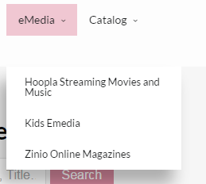hoopla can be accessed from the homepage at ritterpubliclibrary.org. The link is found under eMedia.
2. You can access eBooks, eAudiobooks, Comic Books, TV shows and movies. These items can be borrowed on your smartphone, device or computer and will not have any fees.
3. You are able to check out 10 items per month using your library card.
4. 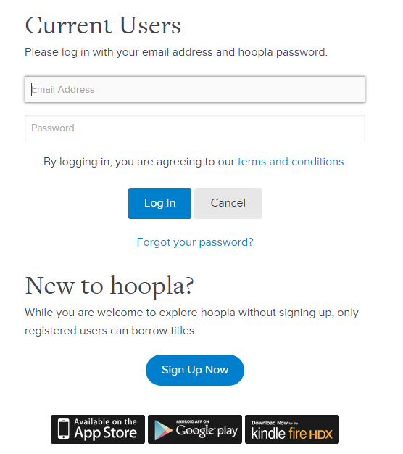Click Log In in the top right corner of the screen. If this is your first time using hoopla, Sign Up Now.
5. 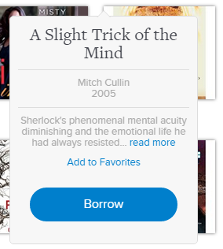Once you are logged in, find the title you are interested in by browsing or searching and click Borrow. The item is immediately available to view.

*Note: hoopla is a streaming service. You will never need to place an item on hold. All the titles they offer will be available at any time.*