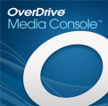Downloading eBooks, Audiobooks and Movies

The updated Overdrive app works the same on most devices, including the Kindle Fire!

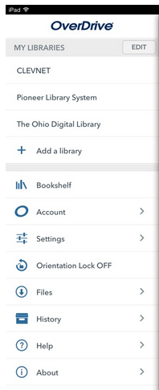Getting Started:

1. Download the free Overdrive Media Console app from your device’s App Store.
2. Open the app and click “Add a library.”

* Search for Cleveland Public library and tap on it.
* Tap the star by CLEVNET to save it.
* You only need to do this once. It will always appear on your Overdrive menu.

1. Tap on CLEVNET on the menu. This will take you to the eMedia catalog.

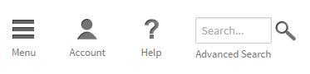Searching:

1. Enter a specific author or title in the search box.
2. If you are just browsing for something, use the Advanced Search. You can select subjects (mystery, adventure, etc.) or format (ePub, audiobook, etc.).

This bookshelf shows items that are on your device.

1. You can filter your search results by selecting options on the left menu – format, availability, etc.

Checking out:

1. The first time you use the app, you’ll need to Sign In to Clevnet. Tap Sign In, in the upper right corner. Enter your library card number and check the box to remember your login information.
2. When you find a title you like, tap the cover image and then tap Borrow.
3. Tap Download to put the item on your device. Select EPUB for ebooks or other desired format > Confirm and Download.

Holds:

1. If the item is not currently available (the format icon is grayed out), you can tap Place a Hold. You will receive an email when it is available.
2. Open the app, tap CLEVNET, and click on Account. The title will already be checked out to you. You’ll see the title on your bookshelf and can download it to your device.

Returning Items:

1. Titles automatically expire at the end of the loan period. You will be prompted to delete them at that time.
2. If you want to return a title early, tap on your Overdrive Bookshelf, then tap / hold on the title. You will get a menu allowing you to return it early.
3. There are no fines and no renewals. You’ll need to check out a title again if you don’t finish it on time.