hoopla Worksheet

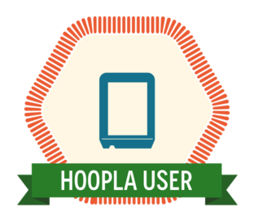

1. On a computer, find hoopla from the homepage at ritterpubliclibrary.org.
2. Create an account using your email address and library card – you will need to create a password.
3. Browse the items available and select an eBook that seems interesting to you.
4. Borrow the eBook and begin reading.
5. Let a coach know if you have any questions and when you have completed this task.

