***This exercise should be completed on a device that has apps. Our mobile lab laptops, Reference or Children’s iPads, staff Samsung Galaxy tablets or your personal device may be used*.**

OverDrive Worksheet

1. 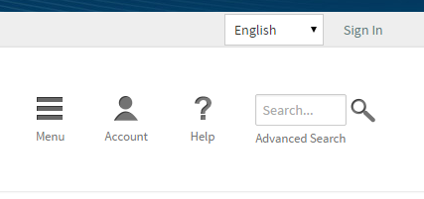Open the Overdrive app. If using a personal device, you may need to download it from your app store.
2. Go to CLEVNET and Sign In – click on Sign In and use your library card number.
3. Enter a favorite author in the search box.

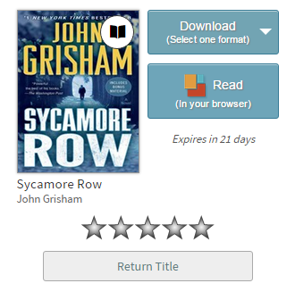

1. Choose an available book (black book icon).
2. Borrow the book.
3. Click Download.

What title did you pick? _______________________________________________

1. Find a title that is unavailable (gray book icon) and Place a Hold on it.

What title did you pick? _______________________________________________

1. 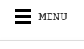Return to the Overdrive app and open the book. Click on Menu on the book page. It may be in the top middle or top left of page.

HINT: When the book is open, you can also tap in the middle of a page to see options.

1. Choose Settings. Try out different settings. Make the font bigger. Change the text from black with a white background to white with a black background. Change the font type. Have fun.

What are your favorite settings? _____________________________________________

________________________________________________________________________