CLEVNET App Instruction

CLEVNET App Worksheet

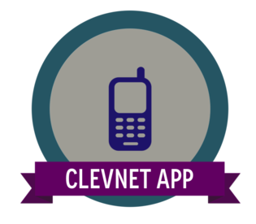

1. The CLEVNET App allows users to search the CLEVNET catalog.
   1. True
   2. False
2. Patrons can see the following items on the CLEVNET App [circle all that apply]:
   1. The items s/he has checked out
   2. Any items that are overdue
   3. Name of his/her favorite librarian
   4. Fines on account
   5. Holds on account and the status of each item
   6. CLEVNET locations with address, phone number and hours
   7. The weather in Cleveland for the month
3. Users can place an item on hold through the CLEVNET App.
   1. True
   2. False
4. The CLEVNET app can be downloaded on an iOS or Android device.
   1. True
   2. False
5. The CLEVNET app can store a library barcode. These barcodes can never be scanned to check out books at Ritter Public Library.
   1. True
   2. False