Bibliocommons Worksheet



1. Go to Bibliocommons. Log In with your library card.
2. Place any book on hold.
3. Search for Go Set a Watchman by Harper Lee. Using the filters, what languages are available in CLEVNET?

_____________________________ _____________________________

1. 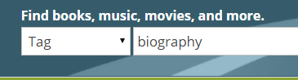Using the Tag option – search biography. Then use the filters on the left side to choose Russia from the Region menu.

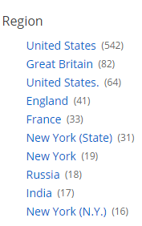

Write down one title from the list:

_____________________________________________________

1. 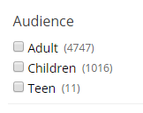Search by keyword – fish. Using the filters choose only books in the children’s area. Go one step further and choose RITTER/Main Library as the location.

Write down one title from the list:

_________________________________________________