Outlook Email Instruction

1. Login - Go to **office.clevnet.org**. Login in using your email address and password.

*Note: You email address password will need to be changed every 6 months. When you are prompted, please contact Paul.*

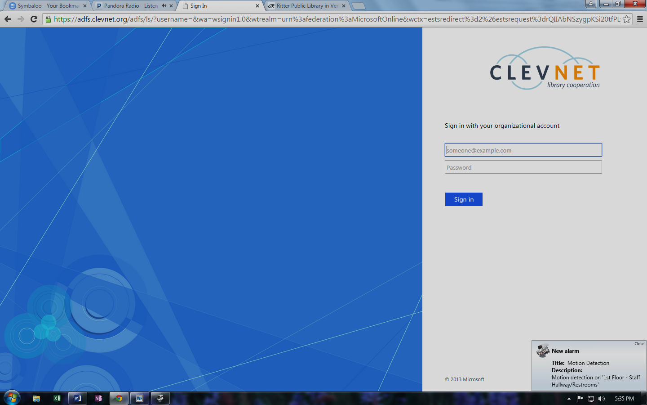



Your menu may look slightly different. The main tools on this menu are the **Mail** and **Calendar** options.

Menu

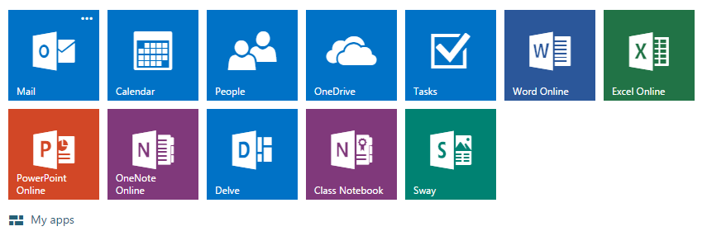

1. 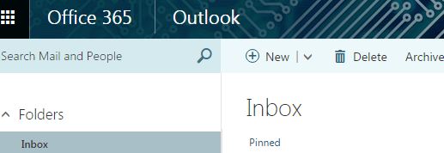Mail

Click on + New to create a new email.

As you add more folders they will appear under More >. To move an email to a folder just drag the email from the Inbox to the correct folder. This will work just like a filing cabinet. Be specific with the titles of the folders and store emails that you will need for a later date.

Click on + to create a new folder. Some examples of folders might be: Tech Challenge, Updates, etc.

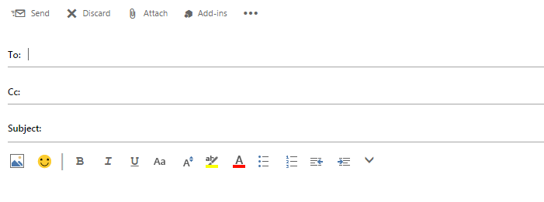

To add an attachment, first know the file you want to attach. Click on Attach – Select Computer – Find file in the R: drive – Select Send as an Attachment.

Type in complete email address – someone@somewhere.com

1. Calendar – every email account has a built in calendar. You are able to add events – work schedule, important dates, meetings, etc.

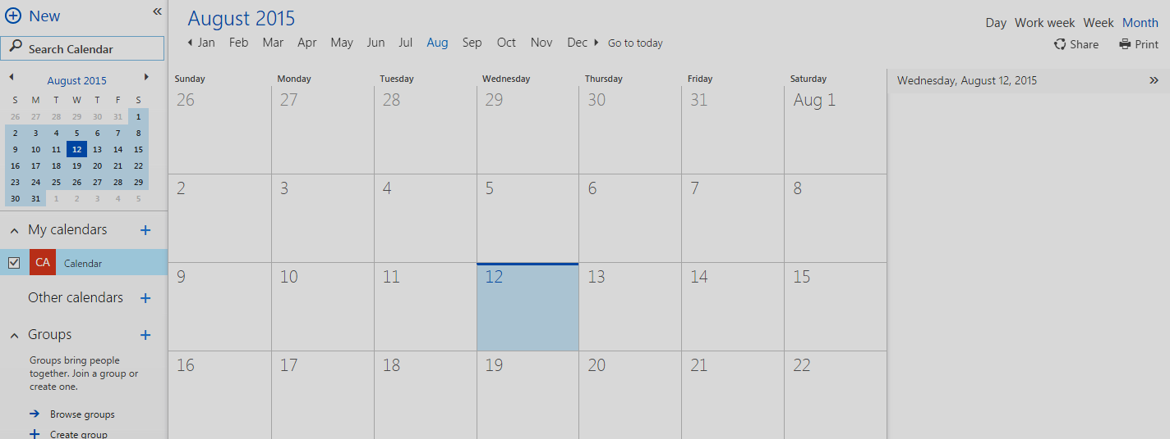

Click + New on the Calendar page to add an event.

The calendar will normally appear on the current month. But you can also look at just the day or week.