Christmas Cookie Recipes



Favorites of Ritter Staff Members

December 2015

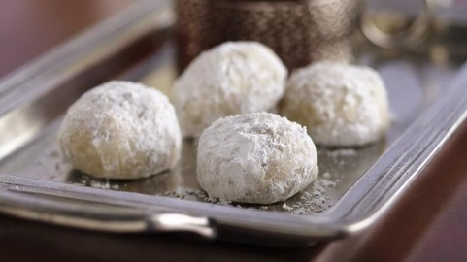Russian Tea Cakes

*Recommended by Patty and Dianne*

* Prep Time: 60 min
* Total Time: 1 hr 15 min
* Servings: 48

Ingredients

1 cup butter or margarine, softened

½ cup powdered sugar

1 teaspoon vanilla

2 ¼ cups Gold Medal™ all-purpose flour

3/4 cup finely chopped nuts

¼ teaspoon salt

Powdered sugar

Directions

Heat oven to 400ºF.

Mix butter, 1/2 cup powdered sugar and the vanilla in large bowl. Stir in flour, nuts and salt until dough holds together.

Shape dough into 1-inch balls. Place about 1 inch apart on ungreased cookie sheet.

Bake 10 to 12 minutes or until set but not brown. Remove from cookie sheet. Cool slightly on wire rack.

Roll warm cookies in powdered sugar; cool on wire rack. Roll in powdered sugar again.

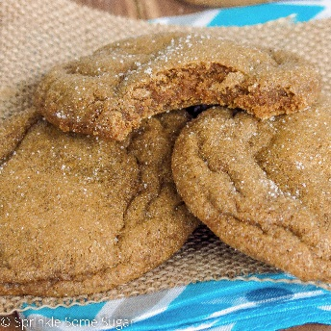Soft Gingersnaps

*Recommended by Carrie*

Ingredients

* 1 cup flour, divided
* 1 cup brown sugar
* ¾ cup shortening
* ¼ cup molasses
* 1 egg
* 1 teaspoon baking soda
* 1 teaspoon ground ginger
* 1 teaspoon ground cinnamon
* ½ ground cloves
* 1 ¼ cups flour
* ¼ cup white sugar

Directions

* Preheat oven to 375 degrees

* Beat 1 cup flour, brown sugar, shortening, molasses, egg, baking soda, ginger, cinnamon, and cloves in a large bowl until thoroughly combined

* Stir in remaining 1 ¼ cup flour.

* Shape dough into 1-inch balls and roll in white sugar

* Place 2 inches apart on an ungreased baking sheet.

* Bake in preheated oven until cookies are set and tops are crackled, 8-10 minutes.

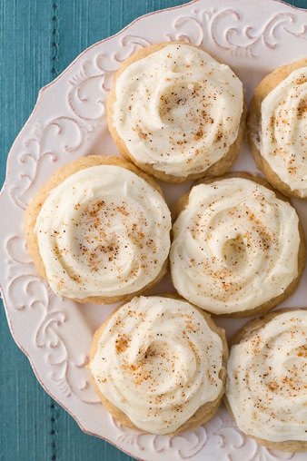Melt-In-Your-Mouth Eggnog Cookies

*Recommended by Ashley*

Prep Time: 30 minutes  
Cook Time: 12 minutes  
Yield: About 32 cookies  
  
**Ingredients**  
2 1/4 cups all-purpose flour   
2 tsp baking powder  
1/2 tsp salt  
1/2 tsp ground nutmeg, plus more for topping  
1/2 tsp ground cinnamon  
3/4 cup unsalted butter, at room temperature  
1/2 cup granulated sugar  
1/2 cup packed light-brown sugar  
2 large egg yolks   
1 tsp vanilla extract  
1/2 tsp rum extract  
1/2 cup eggnog  
Frosting  
1/2 cup butter, at room temperature (I used 1/4 cup salted and 1/4 cup unsalted butter)  
3 - 5 Tbsp eggnog  
1/2 tsp rum extract  
3 cups powdered sugar  
  
**Directions**  
Preheat oven to 350 degrees.

* In a mixing bowl, whisk together flour, baking powder, salt, nutmeg and cinnamon for 30 seconds, set aside.
* In the bowl of an electric stand mixer fitted with the paddle attachment, whip together butter, granulated sugar and brown sugar until pale and fluffy.
* Mix in egg yolks one at a time, blending just until combined after each addition.
* Mix in vanilla extract, rum extract and egg nog.
* With mixer set on low speed, slowly add in dry ingredients and mix just until combined.
* Scoop dough out by the heaping tablespoonfuls and drop onto Silpat or parchment paper lined baking sheets, spacing cookies 2-inches apart.

Bake in preheated oven 11 - 13 minutes. Allow to rest on baking sheet several minutes before transferring to a wire rack to cool. Cool completely then frost with Eggnog Frosting and sprinkle tops lightly with nutmeg.

Eggnog Frosting:  
In the bowl of an electric stand mixer fitted with the paddle attachment (or try a hand mixer since not all of us are made of money and can afford those lovely Kichenaid stand mixers), whip butter until very pale and fluffy. Add in rum extract and 3 Tbsp eggnog and mix in powdered sugar. Add additional eggnog to reach desired consistency.

You could probably add some actual rum in here somewhere and make it a party. Merry December!

[](http://www.christmas-cookies.com/images/recs/candy%20cane%20cookies.jpg)Candy Cane Cookies

*Recommended by Amy C.*

*Makes about 30*

1 cup butter or margarine   
1 cup sifted confectioners’ sugar   
1 egg   
1-1/2 teaspoon almond flavoring OR 3/4 teaspoon peppermint flavoring  
1 teaspoon vanilla extract   
2 1/2 cups all-purpose flour   
1 teaspoon salt   
1/2 cup crushed peppermint candy   
1/2 cup white sugar

Preheat oven to 375 F. Mix butter sugar, egg, and flavorings thoroughly. Add flour and salt, Mix well. Shape dough into a disk and wrap with plastic wrap; chill for at least 2 hours or until easy to handle. Roll into 4 inch strips; place on baking sheet. Curve top down to form handle or cane. Bake 9 minutes. While still warm, remove from pan and sprinkle with candy and sugar mixture.   
  
Dough may be divided in half and colored with 1/2 teaspoon red food coloring if desired. Roll each color into strips, place side by side, press together lightly and twist like a rope.

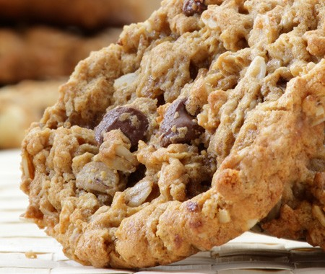Chocolate Chip Cookies

*Recommended by Angie*

15 minutes preparation plus chilling, 10-12 minutes baking per batch. Makes 4 dozen cookies.

Ingredients:

* 1 ½ c. sifted flour
* 1 tsp. baking soda
* 1 tsp. ground cinnamon
* 1 c. (2 sticks) butter, softened
* ½ c. firmly packed brown sugar
* 1 c. granulated sugar
* 1 large egg
* 1 tsp. vanilla extract
* 1 ½ c. old fashioned rolled oats
* 1 c. chocolate chips

Directions:

1. Mix together flour, baking soda and cinnamon.

2. Beat together butter, brown sugar and granulated sugar until light and fluffy. Beat in egg and vanilla.

3. At low speed, beat in flour mixture until blended. Fold in oats and chocolate chips. Cover and chill in refrigerator for 1 hour.

4. Preheat oven to 350F. Grease baking sheets.

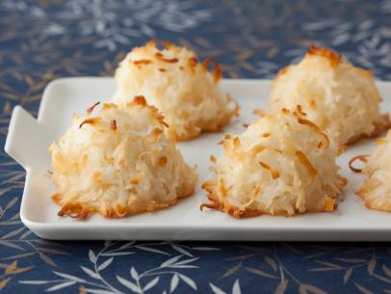Coconut Macaroons

*Recommended by Ann*

My new favorite two-ingredient recipe:

1 (14 oz.) bag sweetened shredded coconut

1 (14 oz.) can sweetened condensed milk

Preheat oven to 350.  Line baking sheet with parchment paper.

Mix the two ingredients together.  Drop by spoonfuls on baking sheet.

Bake 7 - 10 minutes or until flecked with brown spots and crisp around the edges.

Best Ever Spritz Cookies

*Recommended by Karen*

1 cup [Land O Lakes® Butter](http://www.landolakes.com/Products/Butter/), softened

2/3 cup sugar

1 [Land O Lakes® Egg](http://www.landolakes.com/Products/Eggs/)

2 teaspoons vanilla

1/2 teaspoon salt

2 1/4 cups all-purpose flour

Heat oven to 400°F.

Combine all ingredients *except* flour in bowl. Beat at medium speed until creamy. Add flour; beat at low speed until well mixed. Prepare dough as directed by variations below, if desired. (If dough is too soft, cover and refrigerate, 30-45 minutes.)

Place dough into cookie press fitted with template. Form desired shapes, 1 inch apart, onto ungreased cookie sheets.

Bake 6-8 minutes or until edges are lightly browned.

*Variations:  
Chocolate Chip Spritz:* Add 1/4 cup coarsely grated semi-sweet chocolate.

*Eggnog-Glazed Spritz:* Add 1 teaspoon ground nutmeg. Glaze: Stir together 1 cup powdered sugar, 1/4 cup butter, softened, 2 tablespoons water and 1/4 teaspoon rum extract in small bowl until smooth. Drizzle over warm cookies.

*Lebkuchen Spice Spritz:* Add 1 teaspoon ground cinnamon, 1 teaspoon ground nutmeg, 1/2 teaspoon ground allspice and 1/4 teaspoon ground cloves. Glaze: Stir together 1 cup powdered sugar, 2 tablespoons milk and 1/2 teaspoon vanilla in small bowl until smooth. Drizzle over warm cookies.

*Mint Kisses:* Add 1/4 teaspoon peppermint extract. Immediately after removing cookies from oven place *1* chocolate candy kiss on each cookie.

[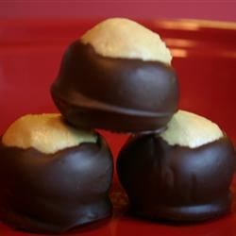](http://allrecipes.com/recipe/9909/buckeyes-i/#next)Buckeyes

*Recommended by Ruby*

1 1/2 cups peanut butter

1 cup butter, softened

1/2 teaspoon vanilla extract

6 cups confectioners' sugar

4 cups semisweet chocolate chips

Directions

1. In a large bowl, mix together the peanut butter, butter, vanilla and confectioners' sugar. The dough will look dry. Roll into 1 inch balls and place on a waxed paper-lined cookie sheet.
2. Press a toothpick into the top of each ball (to be used later as the handle for dipping) and chill in freezer until firm, about 30 minutes.
3. Melt chocolate chips in a double boiler or in a bowl set over a pan of barely simmering water. Stir frequently until smooth.
4. Dip frozen peanut butter balls in chocolate holding onto the toothpick. Leave a small portion of peanut butter showing at the top to make them look like Buckeyes. Put back on the cookie sheet and refrigerate until serving.

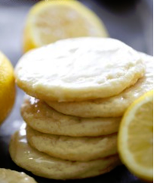Lemon cookies

*Recommended by Dawn*

These cookies are soft, chewy and have the perfect hint of lemon in every bite!

**INGREDIENTS**

1 cup butter, softened

1½ cups sugar

1 egg

1 teaspoon lemon juice

1 Tablespoon Lemon zest

1 teaspoon vanilla

½ teaspoon salt

½ teaspoon baking powder

2¼ cups flour

**Lemon Glaze**

1½ cup powdered sugar

1 Tablespoon lemon juice

1 Tablespoon lemon zest

1 Tablespoon milk

¼ teaspoon vanilla

**INSTRUCTIONS**

1. Preheat oven to 350 degrees F.
2. In a large bowl, cream butter and sugar together.
3. Add egg and beat in well.
4. Add lemon juice, lemon zest and vanilla and mix until well blended.
5. Add salt, baking powder and flour and mix until well incorporated.
6. Roll cookies into 1 inch balls and place on greased cookie sheet. Space cookie dough balls about 2 inches apart from each other.
7. Bake at 350 degrees F for 8-10 minutes or until lightly golden on the edges of cookies.
8. Combine glaze ingredients in a medium bowl and whisk until smooth glaze is formed. Drizzle as much as desired over slightly warmed cookies and let finish cooling completely before eating.

Nut Clusters

*Recommended by Linda*

Not really a cookie, but definitely a family tradition!

Ingredients:

* Chocolate
* Nuts

Melt your favorite chocolate – I prefer milk chocolate chips (one bag), but you can use semi-sweet chips, dark chocolate, candy melts (even colored ones!)

Optional – Add a few drops of salad oil to the chocolate to make it shiny!

Stir in nuts. Use as many as you wish. I use a can of Spanish peanuts. You can also use cashews, almonds, mixed nuts, etc.

Drop by spoonfuls onto waxed paper and let set until hardened.

This makes a quick and easy gift to have on hand. Just put in a decorative tin and Voila!

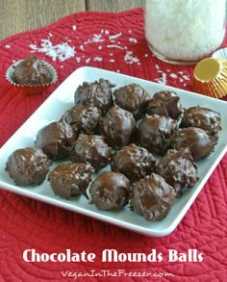MOUNDS BALLS

*Recommended by Cathy*

3/4 cup mashed potatoes

1 lb. powdered sugar

1 lb. unsweetened coconut

Mix. Roll into 1 inch balls. Chill for 2 hours.  Dip in melted chocolate. Chill to harden.

Note: gluten free

(You may use instant potatoes or a real potato to make the mashed potatoes)

## **ITALIAN WALNUT PILLOW http://www.browneyedbaker.com/wp-content/uploads/2009/02/pillow-cookies-17-250-135x135.jpgCOOKIES**

*Recommended by Gaylyn*

***yield:*** Approximately 7 dozen cookies

***prep time:*** 2 hours

***cook time:*** 15-20 minutes

***total time:*** 2 hours

### **INGREDIENTS:**

For the Dough:  
1 cup granulated sugar  
1 cup vegetable shortening  
1 egg  
1 teaspoon vanilla  
1 cup milk (whole, 2% or 1%)  
4½ cups all-purpose flour  
4 teaspoons baking powder  
½ teaspoon salt

For the Filling:  
1½ lbs. walnuts, very finely chopped or ground in a food processor  
½ cup unsalted butter, melted  
1½ cups granulated sugar  
4 egg whites, lightly beaten

For the Icing:  
2 cups powdered sugar  
1 teaspoon vanilla  
4 tablespoons milk

### **DIRECTIONS:**

1. Preheat the oven to 350°. Line two cookie sheets with parchment paper.

2. Make the Dough: In a medium bowl, whisk together the flour, baking powder and salt.

3. Using an electric mixer on medium speed, cream together the sugar and shortening. Add the egg and vanilla and combine well. Add in the remaining ingredients, alternating between the flour mixture and milk, starting and ending with the flour mixture and making sure all of the ingredients are well incorporated. (The dough will be soft.) Divide the dough into four even pieces, wrap each in plastic wrap, and refrigerate for at least 1 hour.

4. Make the Filling: In a large bowl, stir together the chopped nuts and the sugar. Add the melted butter and stir until evenly moistened. Add the egg whites and mix well until completely combined.

5. Assemble the Cookies: On a well-floured surface, roll out a piece of dough into a rectangle measuring about 6 inches by 18 inches. Using an offset spatula, spread one-quarter of the nut filling onto the dough, leaving a small border around the perimeter of the dough. Roll up as you would a jelly roll, with the short ends to the left and right of you, and seal the ends. Cut the roll into 1-inch pieces and place on the prepared baking sheet cut-side-up. Repeat with the remaining pieces of dough and filling (you should be able to fit all of the cookies on two baking sheets.) Bake until the cookies are a light golden brown, about 30 minutes. Transfer the cookies to a wire rack and cool completely.

6. Ice the Cookies: Once the cookies are cooled, whisk together the powdered sugar, vanilla and milk in a small bowl. Dip the tops of the cookies into the icing and let any excess drip off. Allow the icing to set completely before storing. The cookies can be stored in an airtight container at room temperature for up to 2 weeks. These cookies also freeze incredibly well.

Old Fashioned Browned Butter Cookies

*Recommended by Janet*

Butter cookies are great, but nothing can match the unbelievable flavor of browned butter in these cookies.

45 min. prep time 1:30 total time

3 1/2 dozen cookies

1 cup [LAND O LAKES® Butter](http://www.landolakes.com/Products/Butter/)

3/4 cup sugar

1 egg

2 teaspoons vanilla

2 cups all-purpose flour

 Decorator sugars

Melt 1 cup butter over medium-high heat in heavy 2-quart saucepan. Continue cooking, watching closely, until butter foams and just turns a delicate golden color (3 to 5 minutes). Immediately remove from heat; refrigerate 30 minutes.  
  
**Heat oven to 350°F.** Combine browned butter, sugar, egg and vanilla in large bowl. Beat at medium speed until well mixed. Continue beating, gradually adding flour, until well mixed.  
  
Roll dough into 1-inch balls. Roll balls in decorator sugars. Place 2 inches apart onto ungreased cookie sheets. Flatten with tines of fork.  
  
Bake 12 to 15 minutes or until lightly golden brown. Let stand 1 minute; remove from cookie sheets. Cool completely.

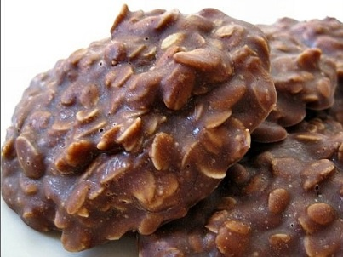No Bake Cookies

*Recommended by Bethany*

Ingredients:

2 cups sugar

½ cup milk

1 stick butter

¼ cup unsweetened cocoa powder

3 cups old-fashioned rolled oats

1 cup smooth peanut butter

1 TBSP pure vanilla extract

Large pinch of salt

Line a baking sheet with wax paper or parchment paper.

Bring sugar, milk, butter, and cocoa to a boil in a medium saucepan over medium heat. Let boil for 1 minute, then remove from heat. Add oats, peanut butter, vanilla, and salt. Stir.

Drop teaspoonfuls of the mixture onto prepared baking sheet, and let sit in refrigerator or freezer until hardened.

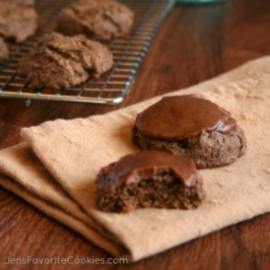Chocolate Frosted Cookies

*Recommended by Amy T*

A chewy, cakey chocolate cookie with chocolate frosting.

Yield: 2-3 dozen

**Ingredients**

**COOKIE:**

½ cup shortening

1 cup brown sugar

1 egg

2 oz. unsweetened chocolate, melted

1 tsp. vanilla

½ cup buttermilk

½ tsp. salt

½ tsp. baking soda

1⅔ cup flour

**FROSTING:**

4 T. butter, melted

½ tsp. vanilla

1 T. cocoa powder

1 tsp. buttermilk

¾ cup powdered sugar

**Instructions**

1. Cream shortening and sugar. Add egg, melted chocolate, and vanilla, and mix well.
2. Add buttermilk, salt, and soda and mix well.
3. Add flour, and mix just until combined.
4. Drop spoonfuls onto baking sheet, and bake at 350 degrees for 10-12 minutes. Remove carefully and allow to cool completely before frosting.
5. For frosting, combine all ingredients, mixing until smooth. Use a small amount of frosting on each cookie.
6. Store in an airtight container between layers of wax paper.



Stir and Drop Sugar Cookies

*Recommended by Joy*

¾ cup sugar

2/3 cup vegetable oil

2 teaspoons baking powder

2 teaspoons vanilla

½ teaspoon salt

2 eggs

2 cups Gold Medal™ all-purpose flour

Additional sugar, if desired

Red and green fruit-flavored gelatins, if desired

Directions

Heat oven to 400ºF.

In large bowl, mix 3/4 cup sugar, the oil, baking powder, vanilla, salt and eggs with spoon. Stir in flour.

Drop dough by teaspoonfuls about 2 inches apart onto ungreased cookie sheet.

Press bottom of glass onto dough to grease, then dip into additional sugar; press on balls until 1/4-inch thickness. Dip bottom of glass onto a wet paper towel, then dip into dry gelatin; press onto dough. Repeat until desired color appears.

Bake 8 to 10 minutes until light brown. Remove from cookie sheet to wire rack. Cool completely.