Working with Images and Clip Art

Using clip art and photos can really liven up a dull document and make it more meaningful. Use special effects sparingly though. Too much of a good thing, isn’t a good thing!

## Inserting pictures from your computer

1. Click the Insert tab.
2. Click Pictures.
3. Locate the picture you want. Double click on it or click the Insert Button.

* Open a blank Word Document.
* Insert a picture from the Pictures Library (Sample folder should have some.)

## Resizing pictures

1. Click on the picture. You will see lines around it and dots on sides and corners.
2. Make your picture larger by clicking and dragging one of the corner dots out.
3. Make your picture larger by clicking and dragging one of the corner dots in.

YOU MUST RESIZE PICTURES USING THE CORNER DOTS OR ELSE YOUR PICTURE WILL LOSE ITS PROPORTIONS!

* Make your picture larger.
* Make your picture smaller.
* Experiment stretching your picture on the sides.

## Moving pictures around the page

1. Be sure your picture is still selected (look for the dots).
2. You will see a new menu at the top:

*YOU MUST CLICK ON YOUR PICTURE BEFORE YOU CAN SEE THE MENU!!*

1. 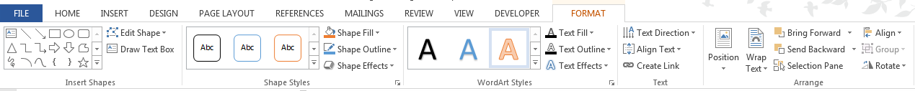Click on the Format tab. You should see this menu with all your options:



1. Look for the Wrap Text icon. It is in the menu bar and also will appear next to your picture.

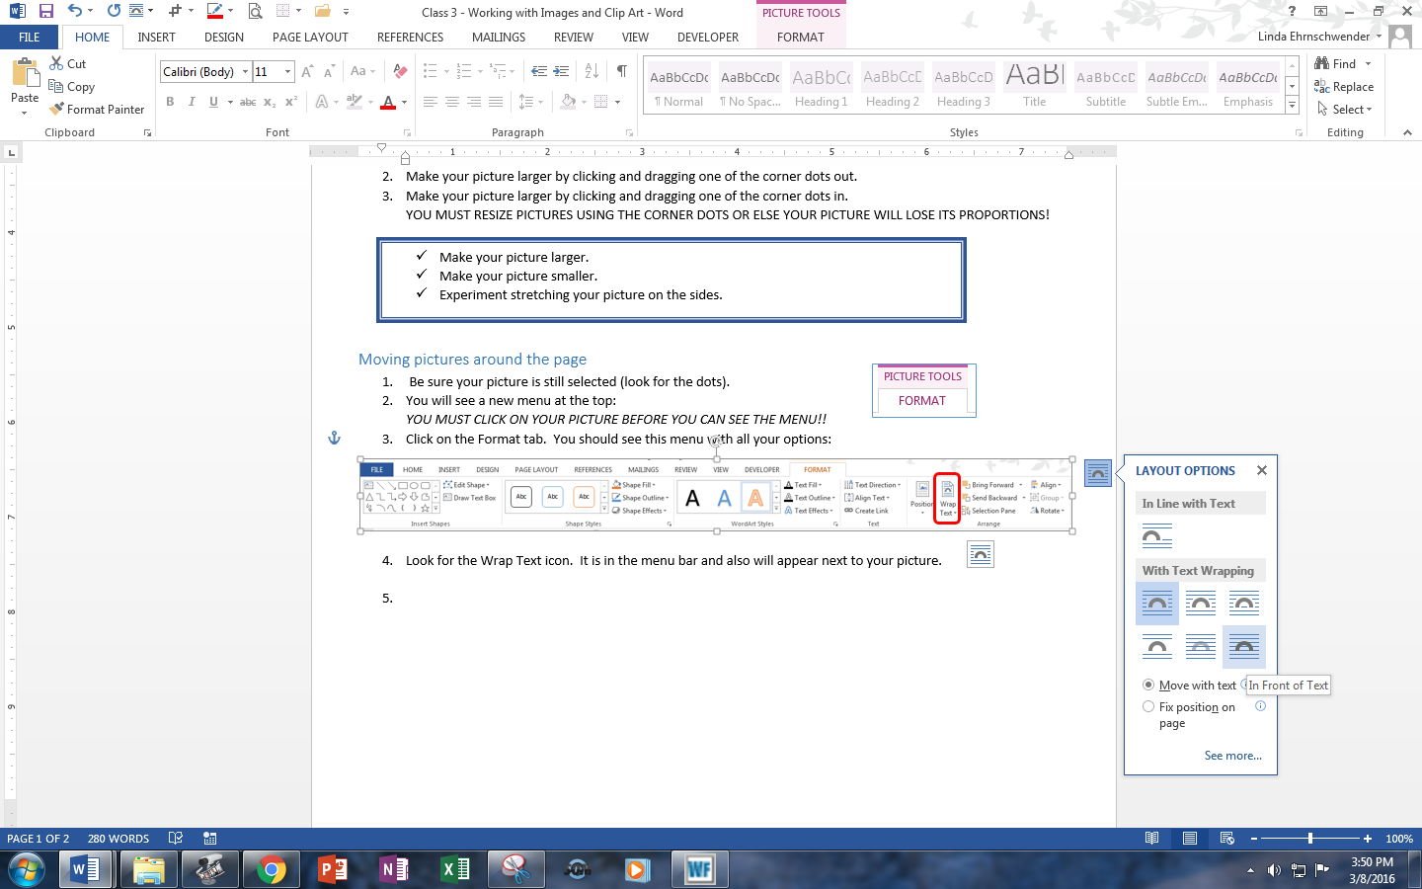

1. In order to easily move your picture around the page, you must select one of the text wrapping options. Then you can just click on it and drag where ever you wish.
2. Hover your mouse over the icons to see the options. If you are inserting it into a document with text, Square works best. If you are making a poster or flyer with little text, try In Front of Text.

* Click on your picture. Use the Text Wrapping icon to select In Front of Text.
* Move the picture around your page.

## Inserting images from the internet

1. Click the Insert tab.
2. Click Online Pictures.
3. Search for an image.
4. Click on the image you wish. Click on Insert.

* Search for an online image – type library
* Insert the picture.
* Resize the picture.
* Make Text Wrap option Square.
* Type LIBRARY next to the picture.
* Move the picture all the way left and right. Watch what happens to the text.



## Twist it!

1. If you don’t want your picture straight, you can rotate it.
2. Be sure the picture is selected. Notice the circular arrow at the top.
3. Click on that arrow and move your mouse left and right. Your picture should twist.

* Click on your library picture.
* Twist it left and right.