Website Instruction

Home page –

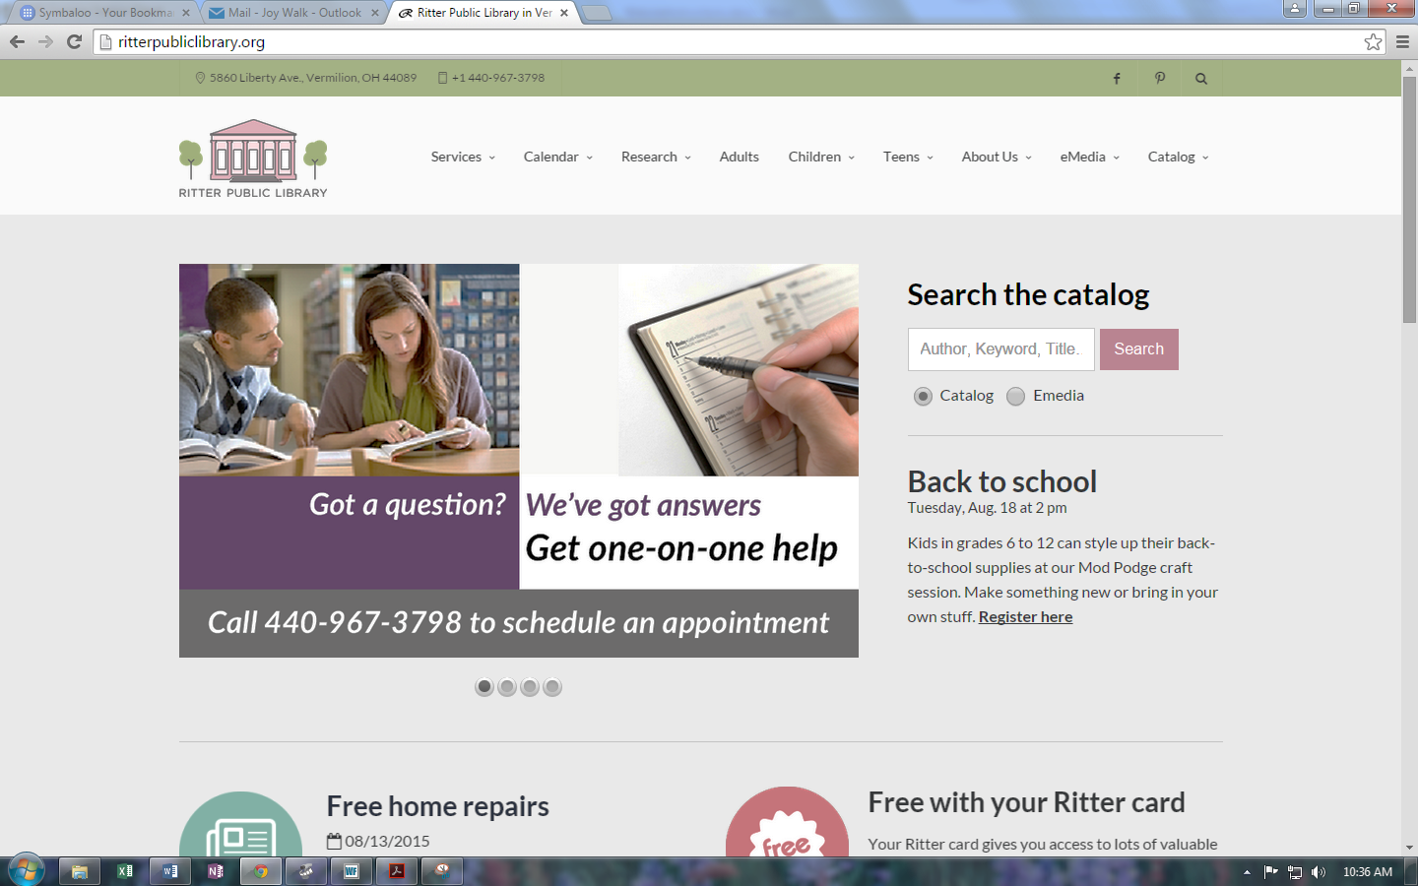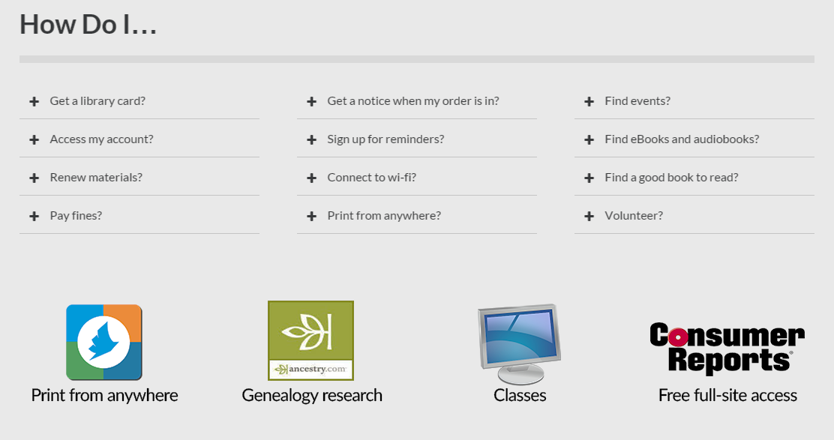

Most of the programs that will require registration will be found here.

Print from anywhere is the link for printing from laptops, smartphones, or devices.

Click on the + to find the answer to the question. Some of the answers have links for additional information. This is handy if you are on the phone with a patron and they need more information about their Clevnet account or NetNotice.

Search in this box by title, author, or subject. This is a Bibliocommons search box. Click on Emedia to search the digital collection.

Click any of these links for more information. If you hover over the link a dropdown menu will appear for other page options.

Home button – Click this button on any page to return to home page.

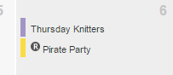Calendar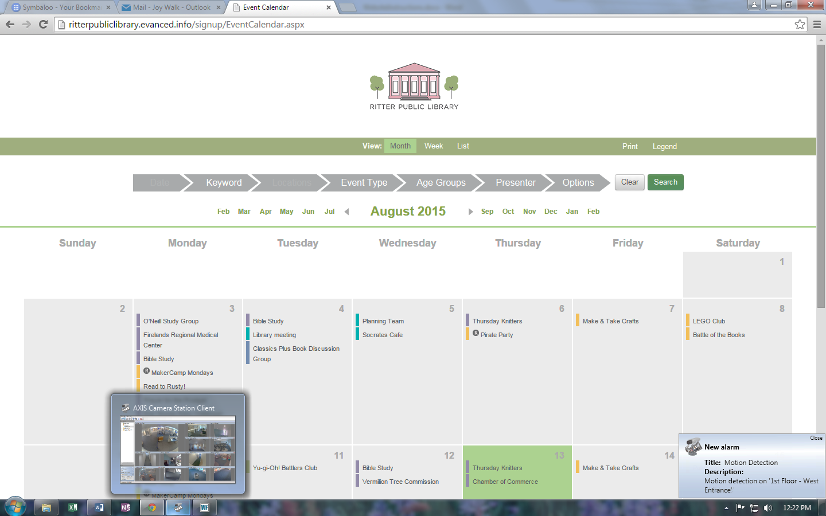

Click on Event Type to filter the events on the calendar by just one type.

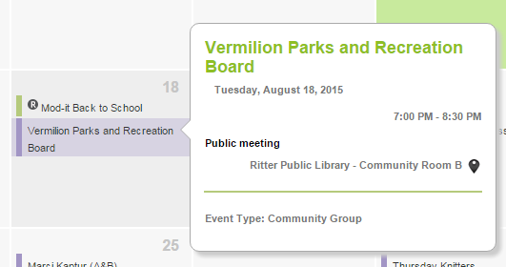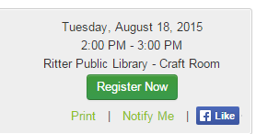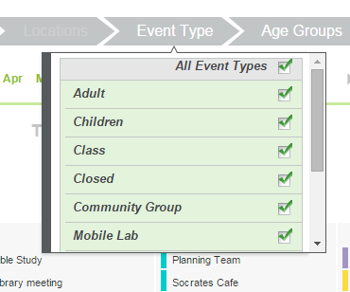

If you click on Notify Me, the patron may be notified by text or email.

Hover over the event with the mouse for the pop up screen to appear. The pop up screen will give you the time, location, group and event type.

To register someone for an event – click on the title of the event and click the green Register Now.