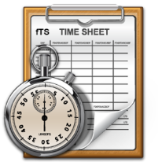

Timesheet Tips

# Make a workbook for the entire year.

1. Open the blank timesheet document and ***SAVE AS*** Timesheet 2016 in your personal folder. From now on, you only have to click SAVE or the Save icon. You don’t need to make multiple documents.
2. Be sure the document is full screen so you can see the tabs at the bottom.



1. ***Right click*** on the Sheet 1 tab.
2. On the pop up menu, ***click Rename.***
3. 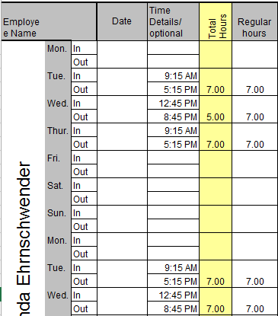***Type*** Master.

# Create a Master time sheet for you.

1. ***Click*** under Employee Name. You should see a long green outlined column.
2. ***Type*** your first and last name. Don’t worry, it will look funny until you hit Enter.
3. You should see your name sideways in that first column.
4. Now ***add your normal schedule***. Don’t worry about the dates.
5. ***Save*** your work.

***NOTE:*** *You will not make any more changes to this sheet unless your normal schedule changes.*

# Copy your Master for the next time period.

1. ***Right click*** on the tab that says Master.
2. ***Click*** Move or Copy.
3. ***Click*** on Sheet 2.
4. ***Check*** Create a copy.
5. ***Click*** OK.
6. ***Right click*** on the Master (2) tab.
7. On the pop up menu, ***click Rename.***
8. Put the date of the time period. You can use beginning or ending date – whichever works best for you. Just be consistent.

# Customizing the Master for the time period

1. 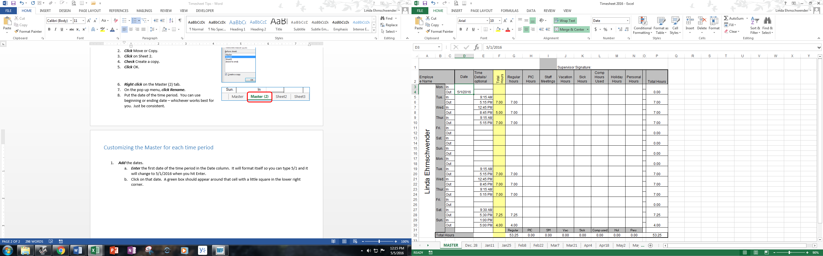 ***Add*** the dates.
   1. ***Enter*** the first date of the time period in the Date column. It will format itself so you can type 5/1 and it will change to 5/1/2016 when you hit Enter.
   2. Click on that date. A green box should appear around that cell with a little square in the lower right corner.
   3. 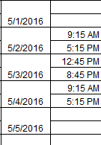Click on that little square and drag it down to the end of the column. The dates will magically appear when you lift your finger off the mouse button!
2. ***Make any changes*** to your normal schedule if needed – sick time, vacation, holidays, shift changes, etc.
3. ***Double check!*** Your hours and totals should calculate for you, but be sure they’re correct.
4. ***Save.***

# Repeat!

1. When it’s time for the next timesheet, repeat:
   1. ***Copy*** the master.
   2. ***Customize*** the master for the time period.
   3. ***Save***.

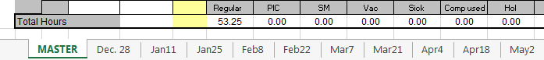Your timesheet workbook will begin to look something like this: