**Wireless Printing Procedures**

**Using a laptop**:

NOTE: When using an Apple computer, please save your document as a PDF file.

1. Start from the Ritter home page: [www.ritterpubliclibrary.org](http://www.ritterpubliclibrary.org).

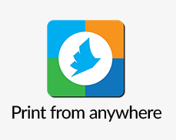

1. Click on Print from Anywhere located near the bottom of the homepage.
2. Using the Welcome Screen:
3. Type in a user name (you will use this at the Circulation Desk to identify your document)
4. 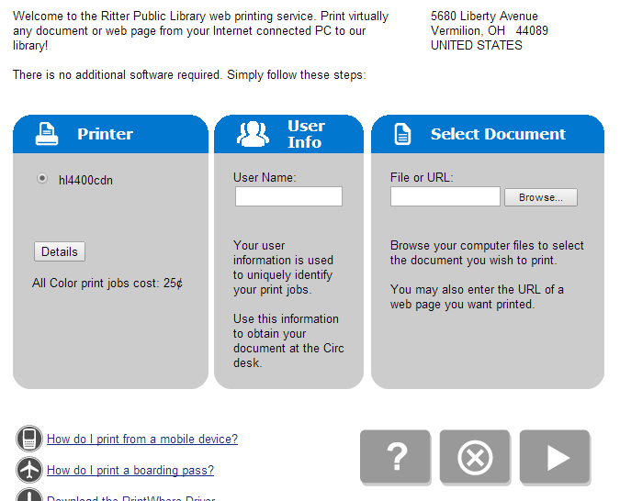Use the Browse button to locate the file on your computer. (Remember: Apple computers require a PDF file to send.)
5. Click on the right arrow.
6. Select the number of copies and the pages you would like to print. Click the right arrow to continue.

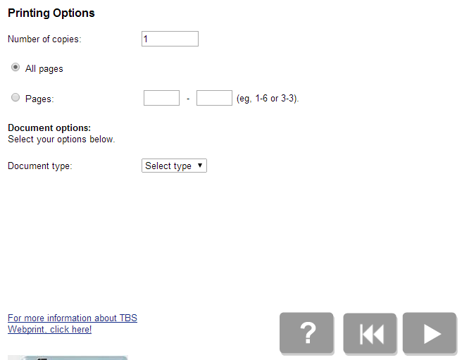

1. Verify the information on the screen and click on the green printer button.

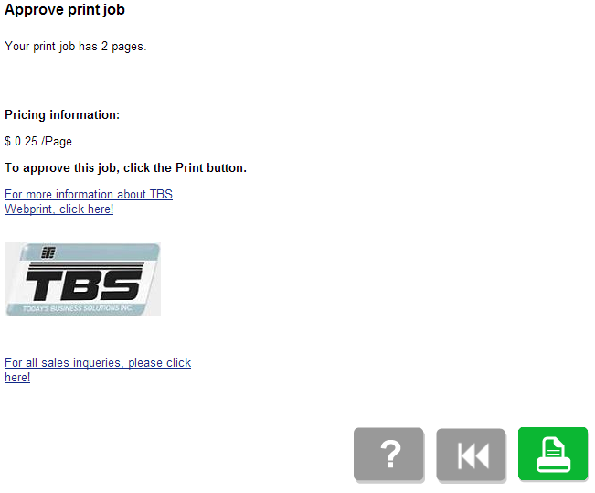Please pick up your documents at the Circulation Desk.

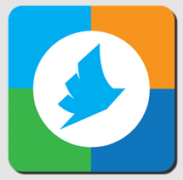**Using a tablet or smartphone**:

1. Install the App – PrinterOn from your app store.
2. Tap on **No Printer Selected.**

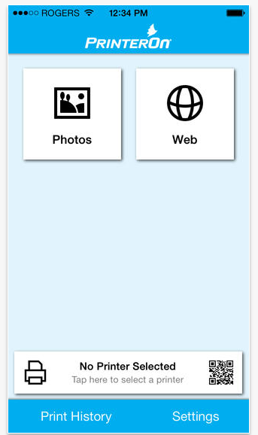

1. Search by Location – be sure your Settings allow for Use Your Location. Select **Ritter Public Library Vermilion** and **Save Printer**.



1. 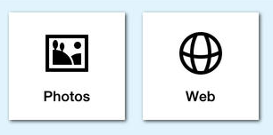Print from Photos or Web. Tap on printer icon in upper right corner.

NOTE: Apple products will not print from Apple office (Pages, Numbers, etc.) Print as image, PDF, or

URL.

Please pick up documents from the Circulation Desk.