Printing Instruction

***Printing depends on the program you are using when you print.***

**Printing from Microsoft Office** – Word, Excel, PowerPoint, etc.

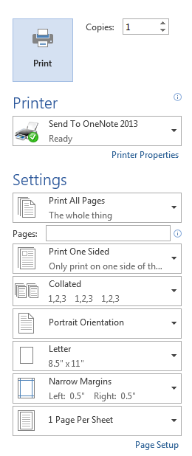Use the File button or the Home button in the top left corner. Select Print.

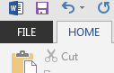 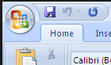

Be sure to look at the options on the printer screen.

* Select the number of copies you would like.
* Choose the correct printer.
* If you are only interested in printing some of the pages – type in the page numbers separated by commas in the Pages: box.
* Click on Print on this screen.



**Printing from email**

In Outlook (and with many other email services) there is often a menu or more option at the top of the email.

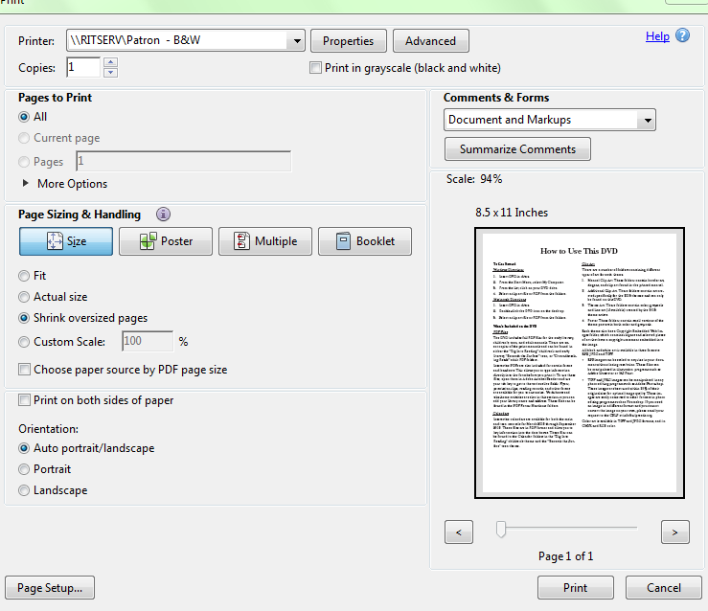

**Printing from Adobe**

Use the File tab in the top left corner and select Print.

The print screen may look like this:

Choose the correct options for printer, number of copies and pages to be printed.

Note: Sometimes Adobe files must be downloaded before they can be printed.