Bibliocommons Instruction

1. 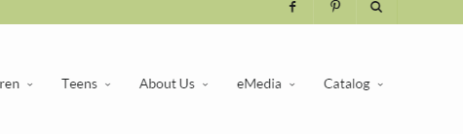To access Bibliocommons – click on the Catalog link on the homepage at ritterpubliclibrary.org.
2. Search the catalog by keyword, author or title.
3. Filter the results by using the choices on the left side of the screen.

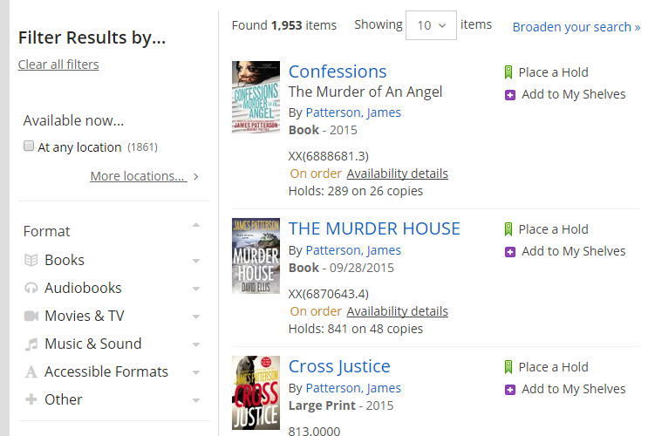

Click on More Locations to select RITTER/Main Library

Select other filters to find the exact item. Books > Book, Large Print, eBook

1. 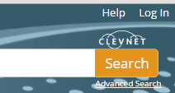To place an item on hold – click Place a Hold [this will prompt you to sign in with a library card number] or Log In first in the top right corner of the screen.

The log in is all of the numbers on the back of the library card – no spaces. The pin is the last four digits of the phone number used when creating a library card account.