Borders and Text Boxes

# Page Border

1. Click on the Design tab.
2. 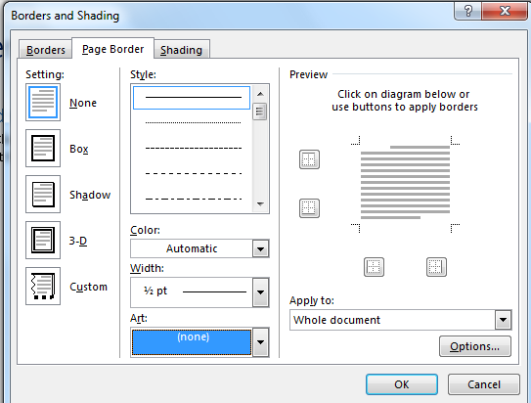At the far right, click on Page Borders.

Use the Art menu to select a predesigned border.

Then scroll to select type of line. You can also choose color and width of line.

Choose the setting of border you’d like.

* Open a blank Word Document.
* Click on the Design tab, then Page Border.
* Experiment with the different settings, widths, and colors.
* Use the Art menu to make a colorful border.

# Text Boxes

1. Click on the Insert tab. Click on Text Box.

This is a Text box.

1. Choose Simple text box.
2. A box will appear on your document. You can click and drag it wherever you wish.
3. Delete the text in it and add your own.
4. Using the dots on the box’s sides, resize it to fit your text.
5. 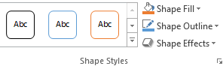Click on your box and then click on Format at the top of your screen. This will display a new menu so you can edit your text.
6. Explore the preset styles.

* Click on the Insert tab.
* Select Text Box.
* Experiment with the different preset styles.
* Choose Shape fill and make it none.
* Choose Shape Outline and make it none.

1. To place text without any special effects, change Shape Fill to No Fill and Shape Outline to No Outline.