Bullets and Lists
Using bullets and lists can make a document easier to read. They’re also handy for sign-up sheets!

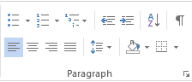
Accessing them
- Click the Home tab.
- The third section of the menu bar has the paragraph related items.
- The first icon is bullets.
- The second icon is for a numbered list.
- Open a blank Word Document.
- Click on the Home tab.

Creating a list
- Put your cursor where you want the list to start.
- Click on the bullet or numbered list icon.
- A bullet or 1. should appear where your cursor is.
- Type the first item.
- When you press Enter, a second bullet or number will appear and you can begin typing next item.
- Click on the bullet icon.
- Type the 4 seasons into a bulleted list.

Changing the type of list
- If you type a bulleted list and decide you’d rather have a numbered list, it’s easy to change.
- Highlight the bulleted text.
- Click the numbered list icon.
- Change your seasons list to a numbered list.

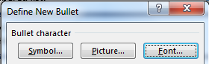
Customize your bullets
- Click on the arrow by the bullet icon. You’ll see a few different bullets there.
- Click on Define New Bullet.
- Click on Symbol.
- Use the scroll bar on the right to see all your options.
- Look for a book, smiley face, star and a snowflake.
- Click OK.
- Pick a bullet design of your choice.
- Change your seasons list to the new bullet you chose.

