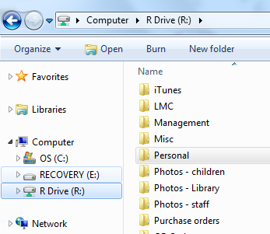The R Drive

## Access

* ***Only accessible from staff computers***.
* Use File Explorer and look under Computer.
* Click to see files.

## Organization

* Each **department** has a folder in which team members can put documents for all of them to share.
  + *Work together as a department to organize material in your folder.*
* Each **person** has a personal folder. You can keep personal files in there and organize as desired. You cannot access another person’s folder or Management’s files.
* There are also folders containing info for everyone such as Forms and Documents .

## Rules

* Do not move or delete another person’s files!
* Organize your own files. Periodically go through and delete outdated items.

## Adding subfolders to your Personal Folder

* 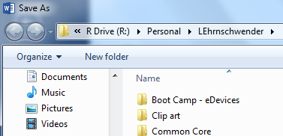When saving a document for your reference, navigate to your personal folder and click on New folder.
* You’ll see a box with “New Folder” added. 
* Rename the folder. Some suggestions would be Tech Challenge, Time off requests, etc.
* Now when saving saving similar documents, you can put them all in the appropriate folder.
* Remember: This is for items only of interest to you, not for department items.

## Create a Shortcut!

* Open File Explorer
* Navigate to your personal folder.
* Click on the Folder icon for the folder you want to move.
* Drag it to the left side bar under Favorites. You should see a popup that says Create Link on Favorites.
* Now when you want to save something to your folder, you can just click on it under Favorites. You can also click on it to quickly open your folder.

* Navigate to your personal folder.
* Create a subfolder called Tech Challenge.
* Create another folder called Time off requests.
* Create a shortcut to your personal folder.

Tech Coaches will be glad to help if you are having difficulty doing this.